Homework #6

Tableau

Group Name: Royal Challengers

Raghava Devaraje Urs

Kumuda Benakanahalli Guruprasada Murthy

Sheema Murugesh Babu

Arpitha Gurumurthy

**Homework 4**

**Tableau Companion Workbook**

In this assignment, we downloaded the free trial of Tableau and performed the view creation as per the image examples shown in companion workbook.

**Pre-Requisites**

Tableau registration using SJSU email account to get the Tableau Desktop software.

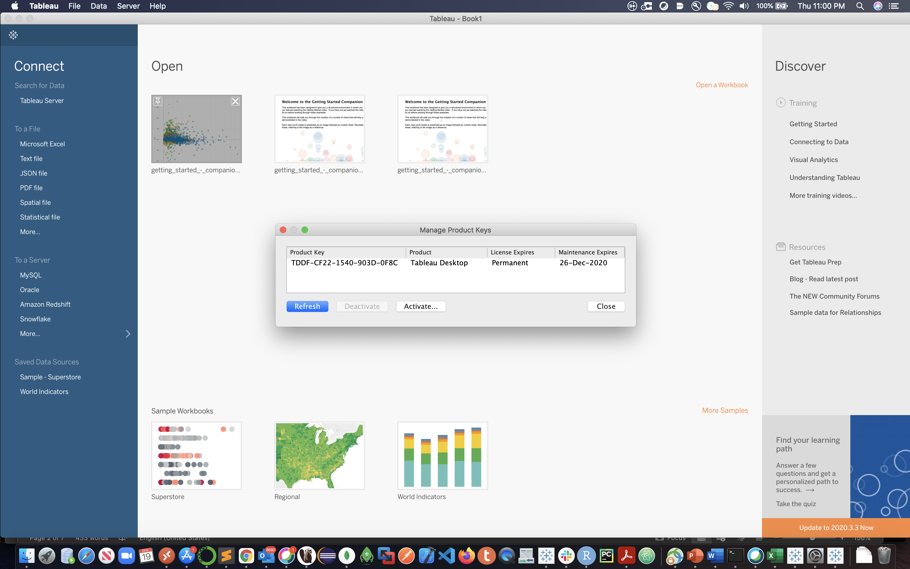

**Working on Companion Workbook**

* Open the Companion Workbook given in the assignment. This will open the Tableau Desktop and will open the companion workbook

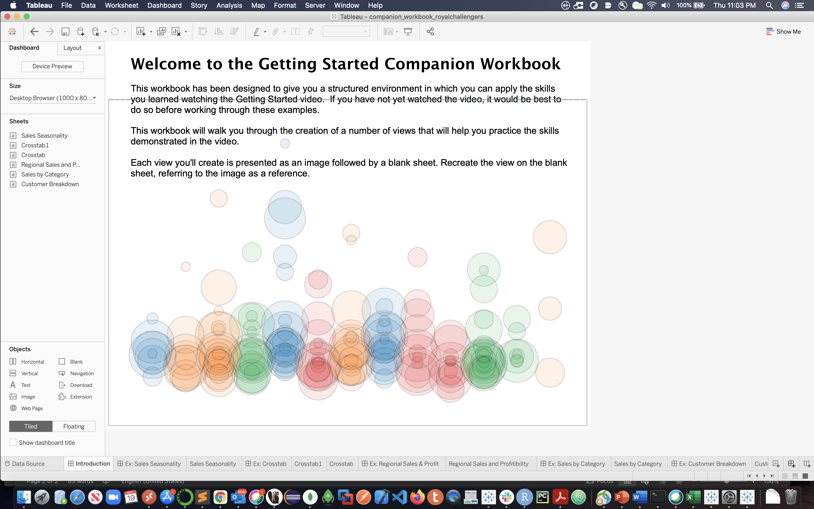

In this workbook, Superstore Subset sample data source is preloaded. The connection setting is set to Live.

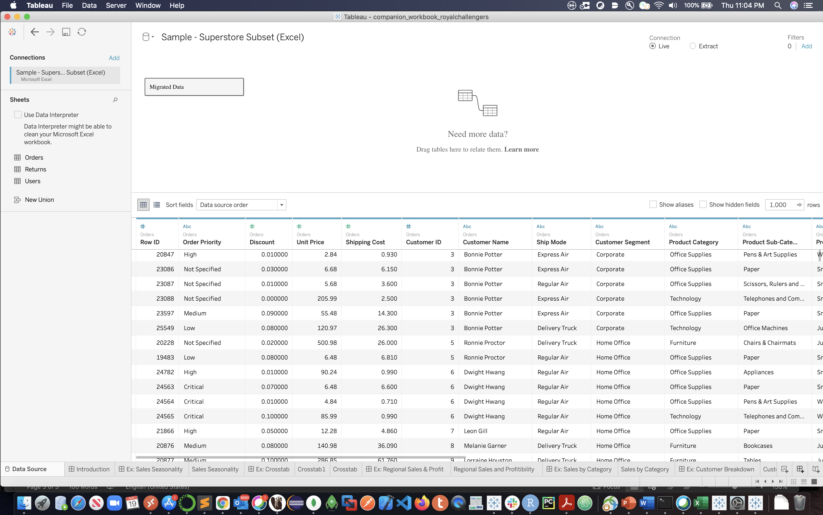

Following worksheets are created as part of the workbook.

1. Sales Seasonality

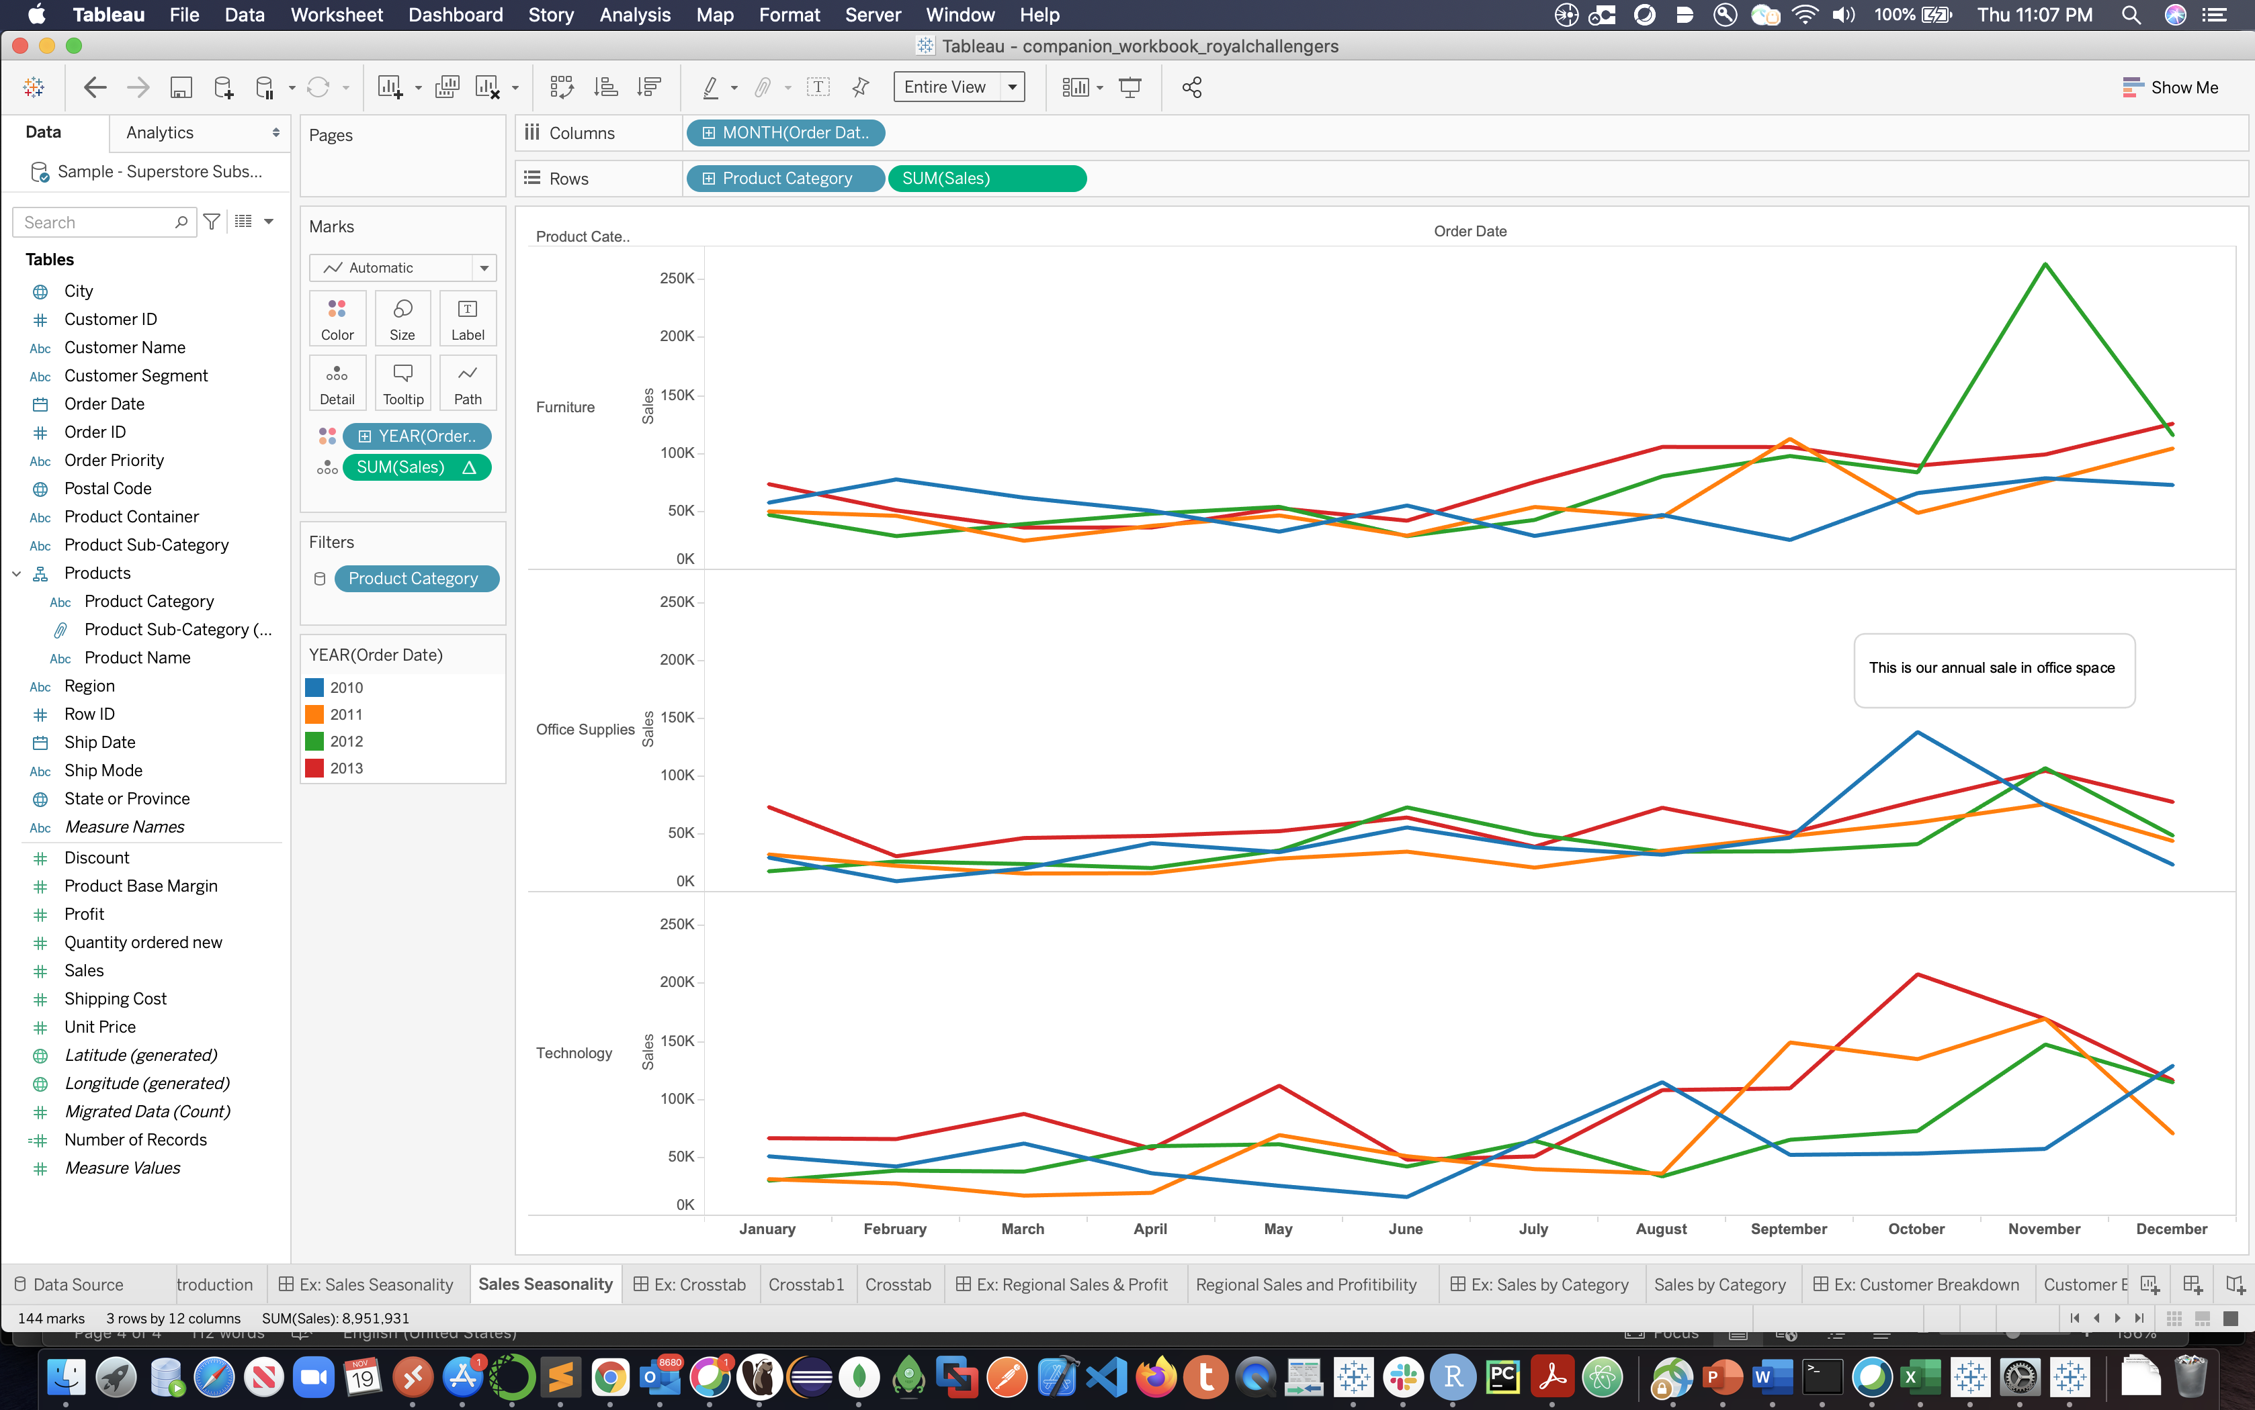

1. Crosstab for sales seasonality

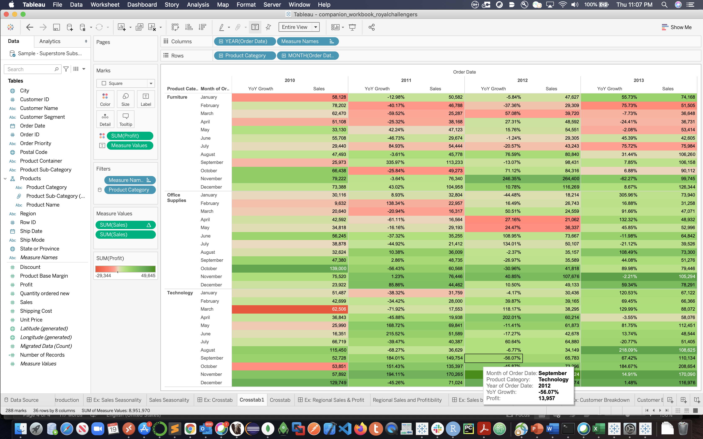

1. Regional Sales and Profitability

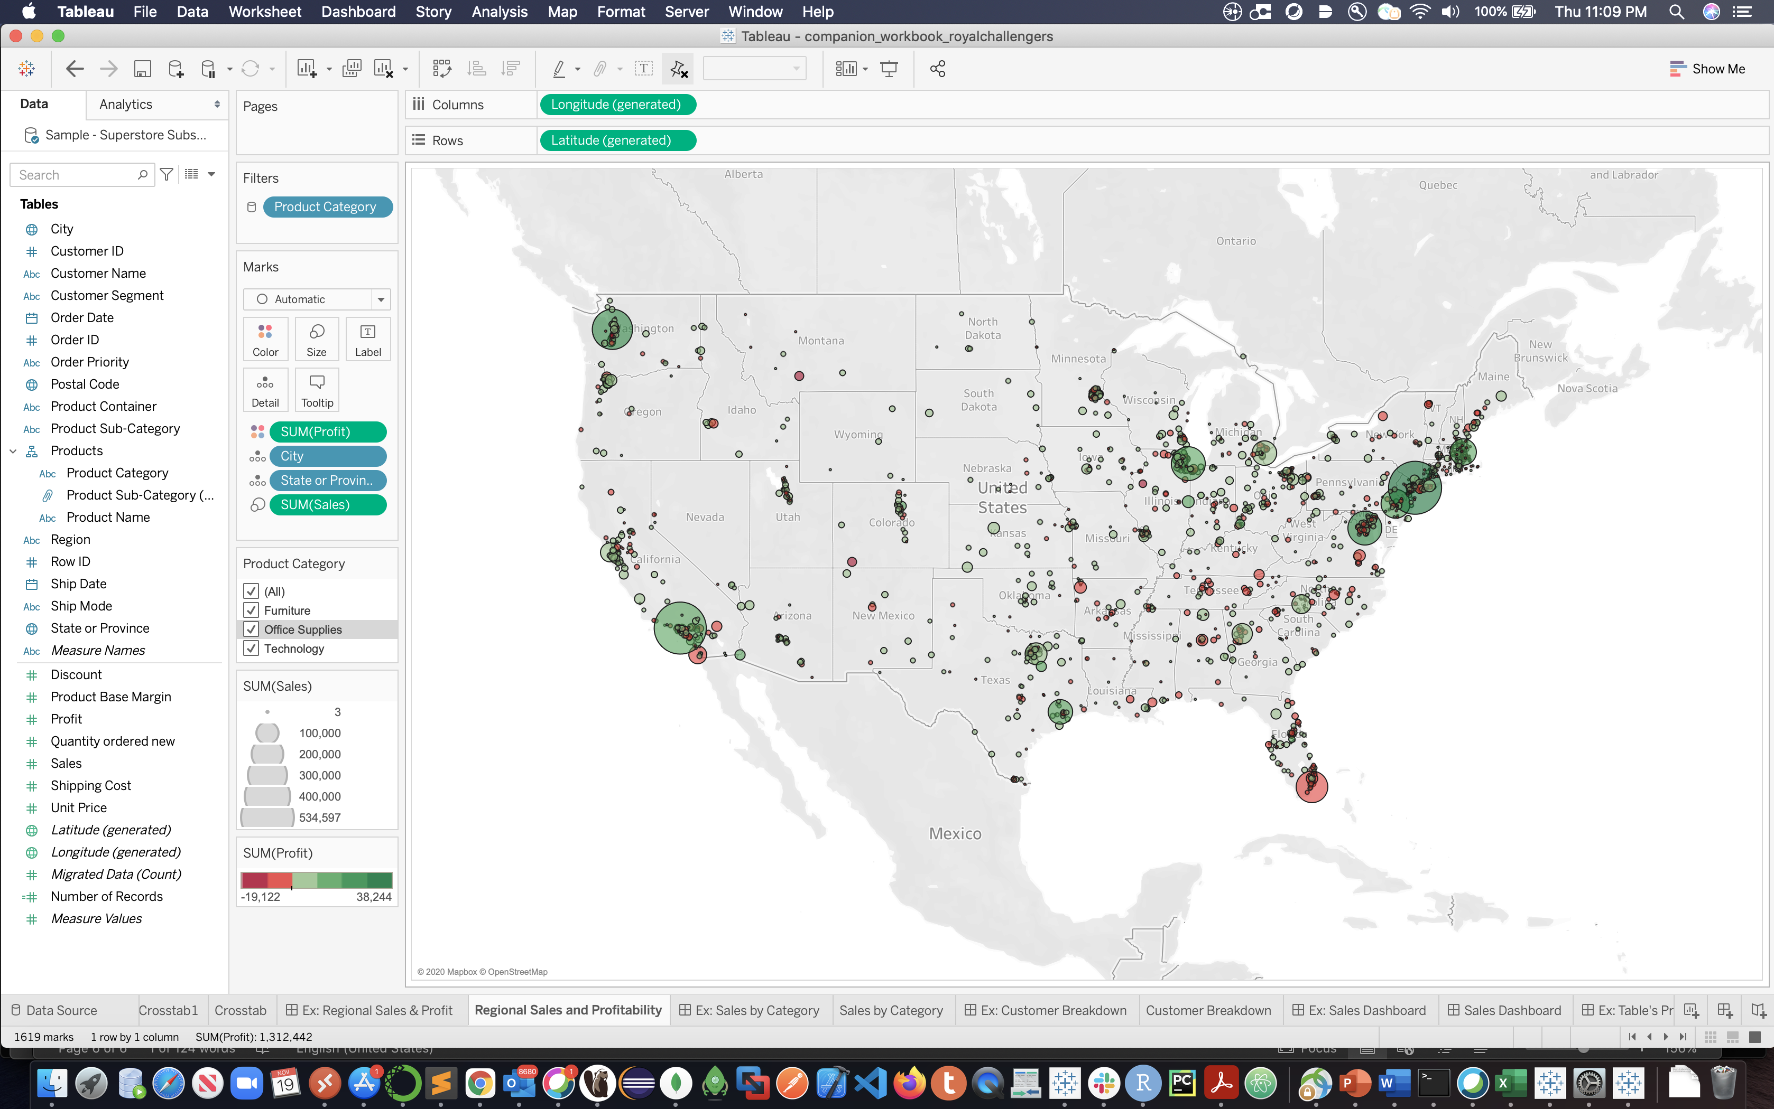

1. ﻿Sales by Category

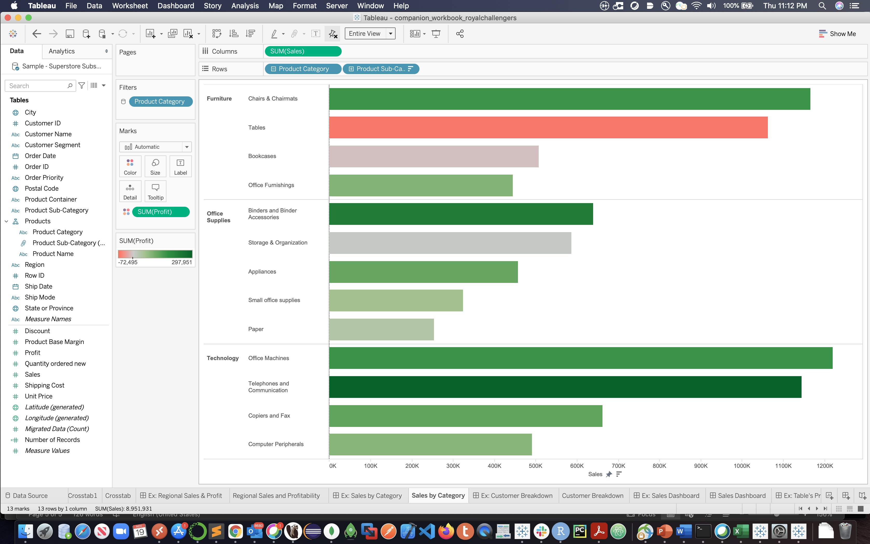

1. Customer Breakdown

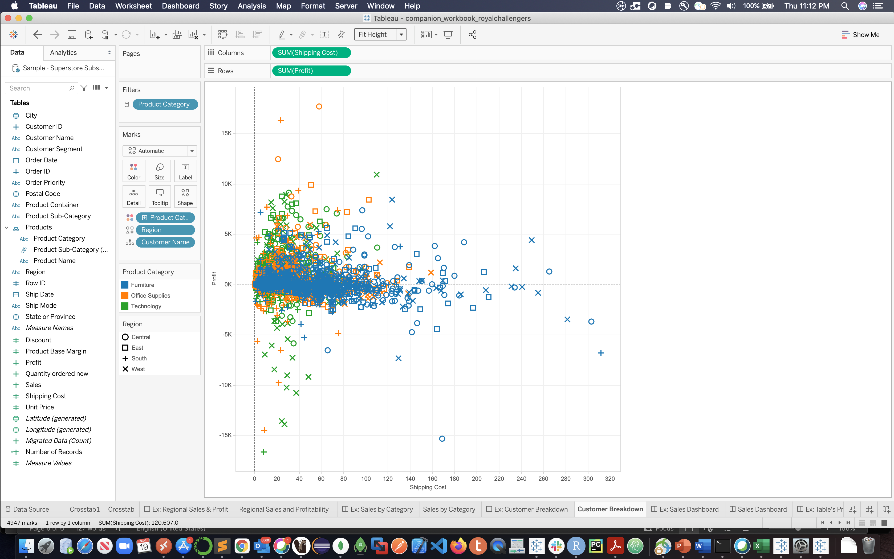

1. Sales Dashboard

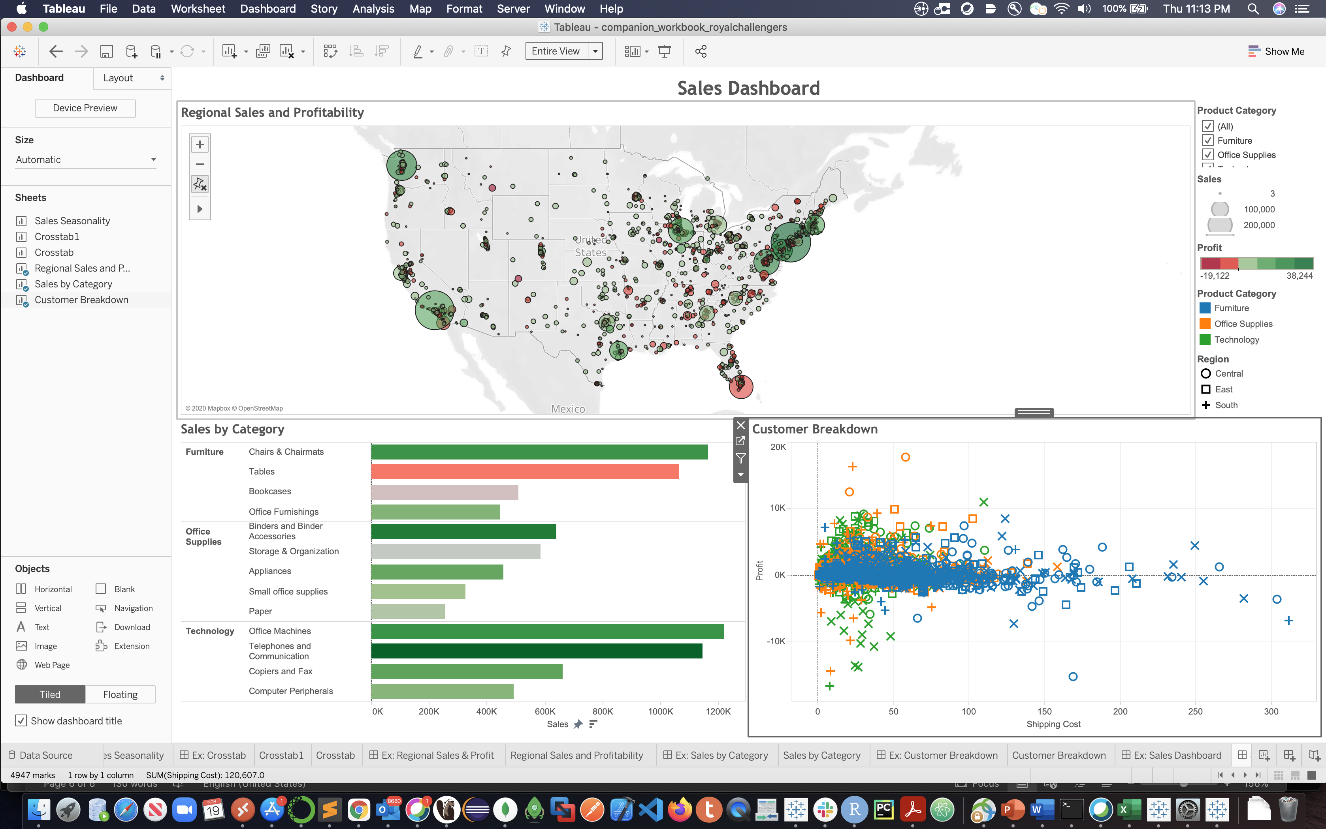

1. Table’s Profitability: Storybook

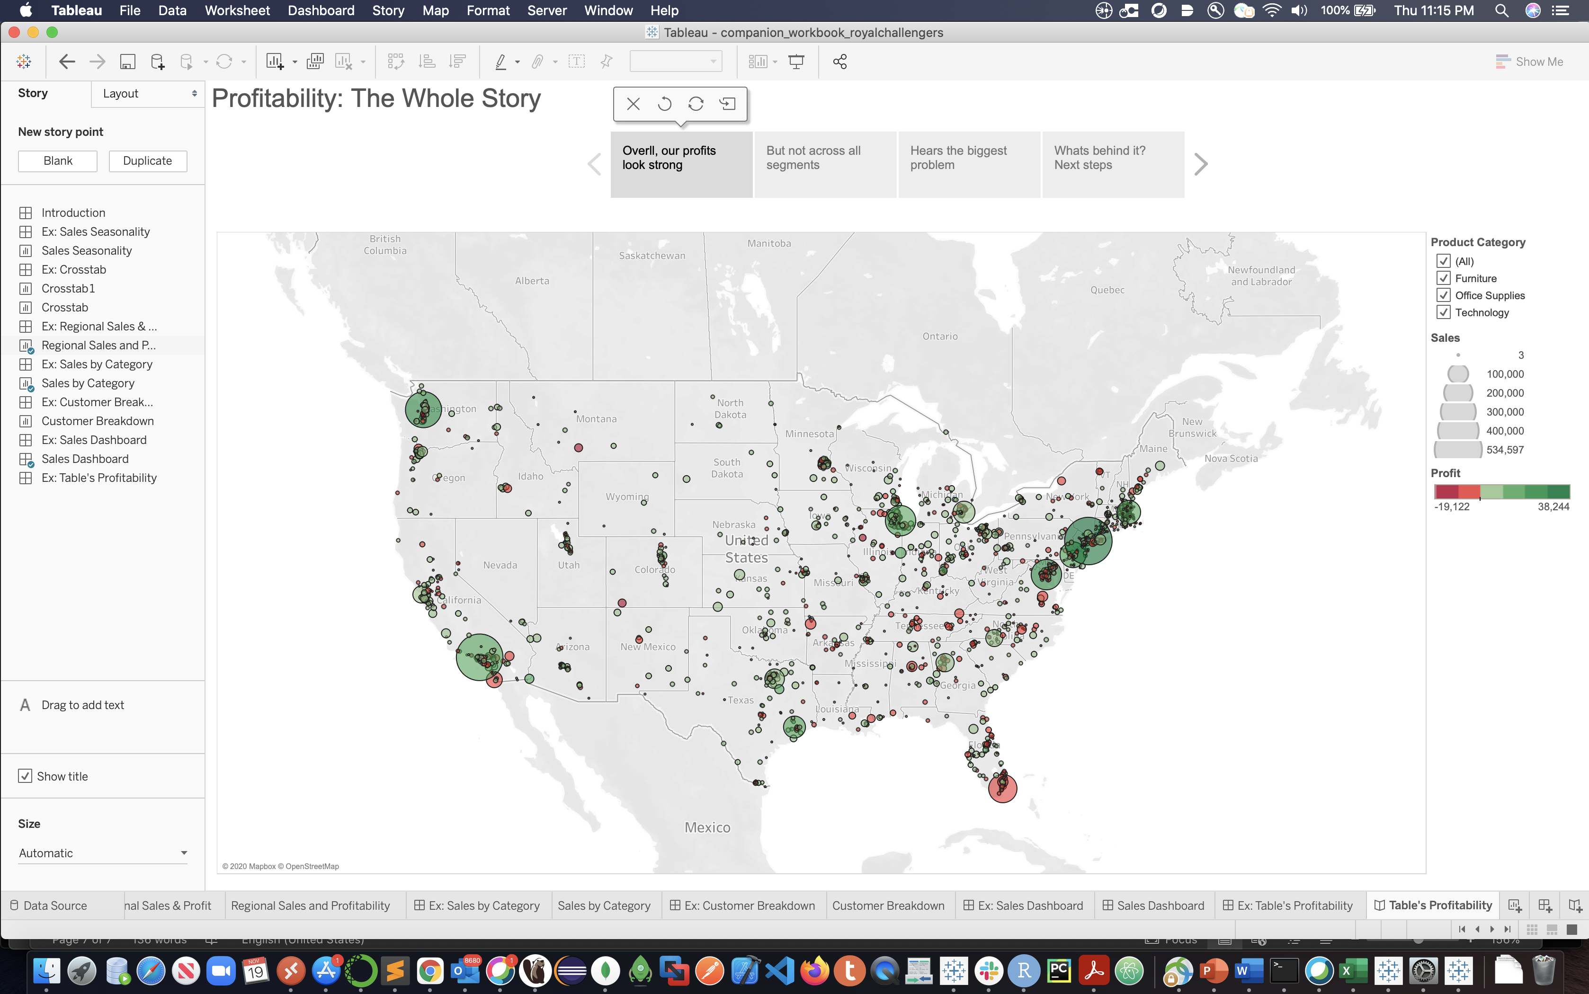

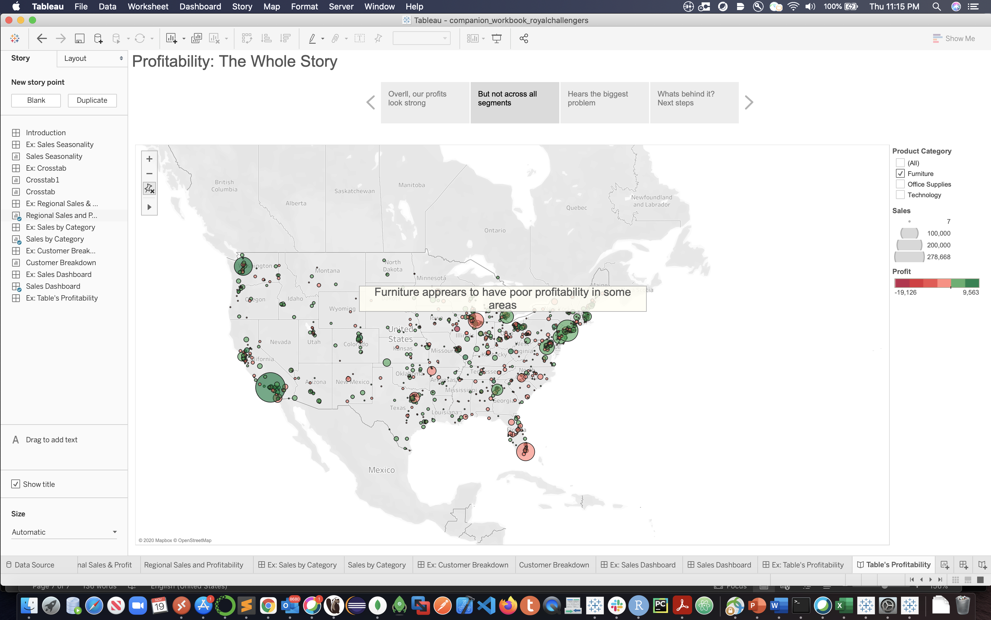

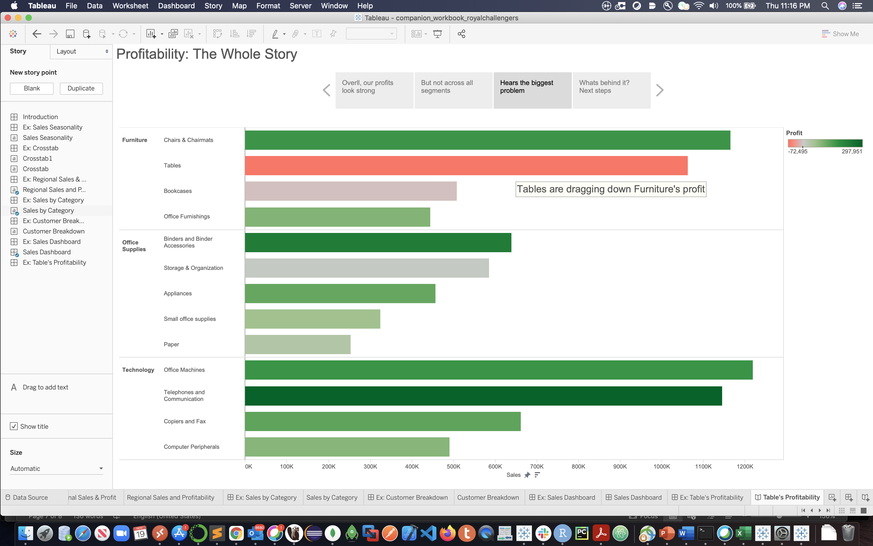

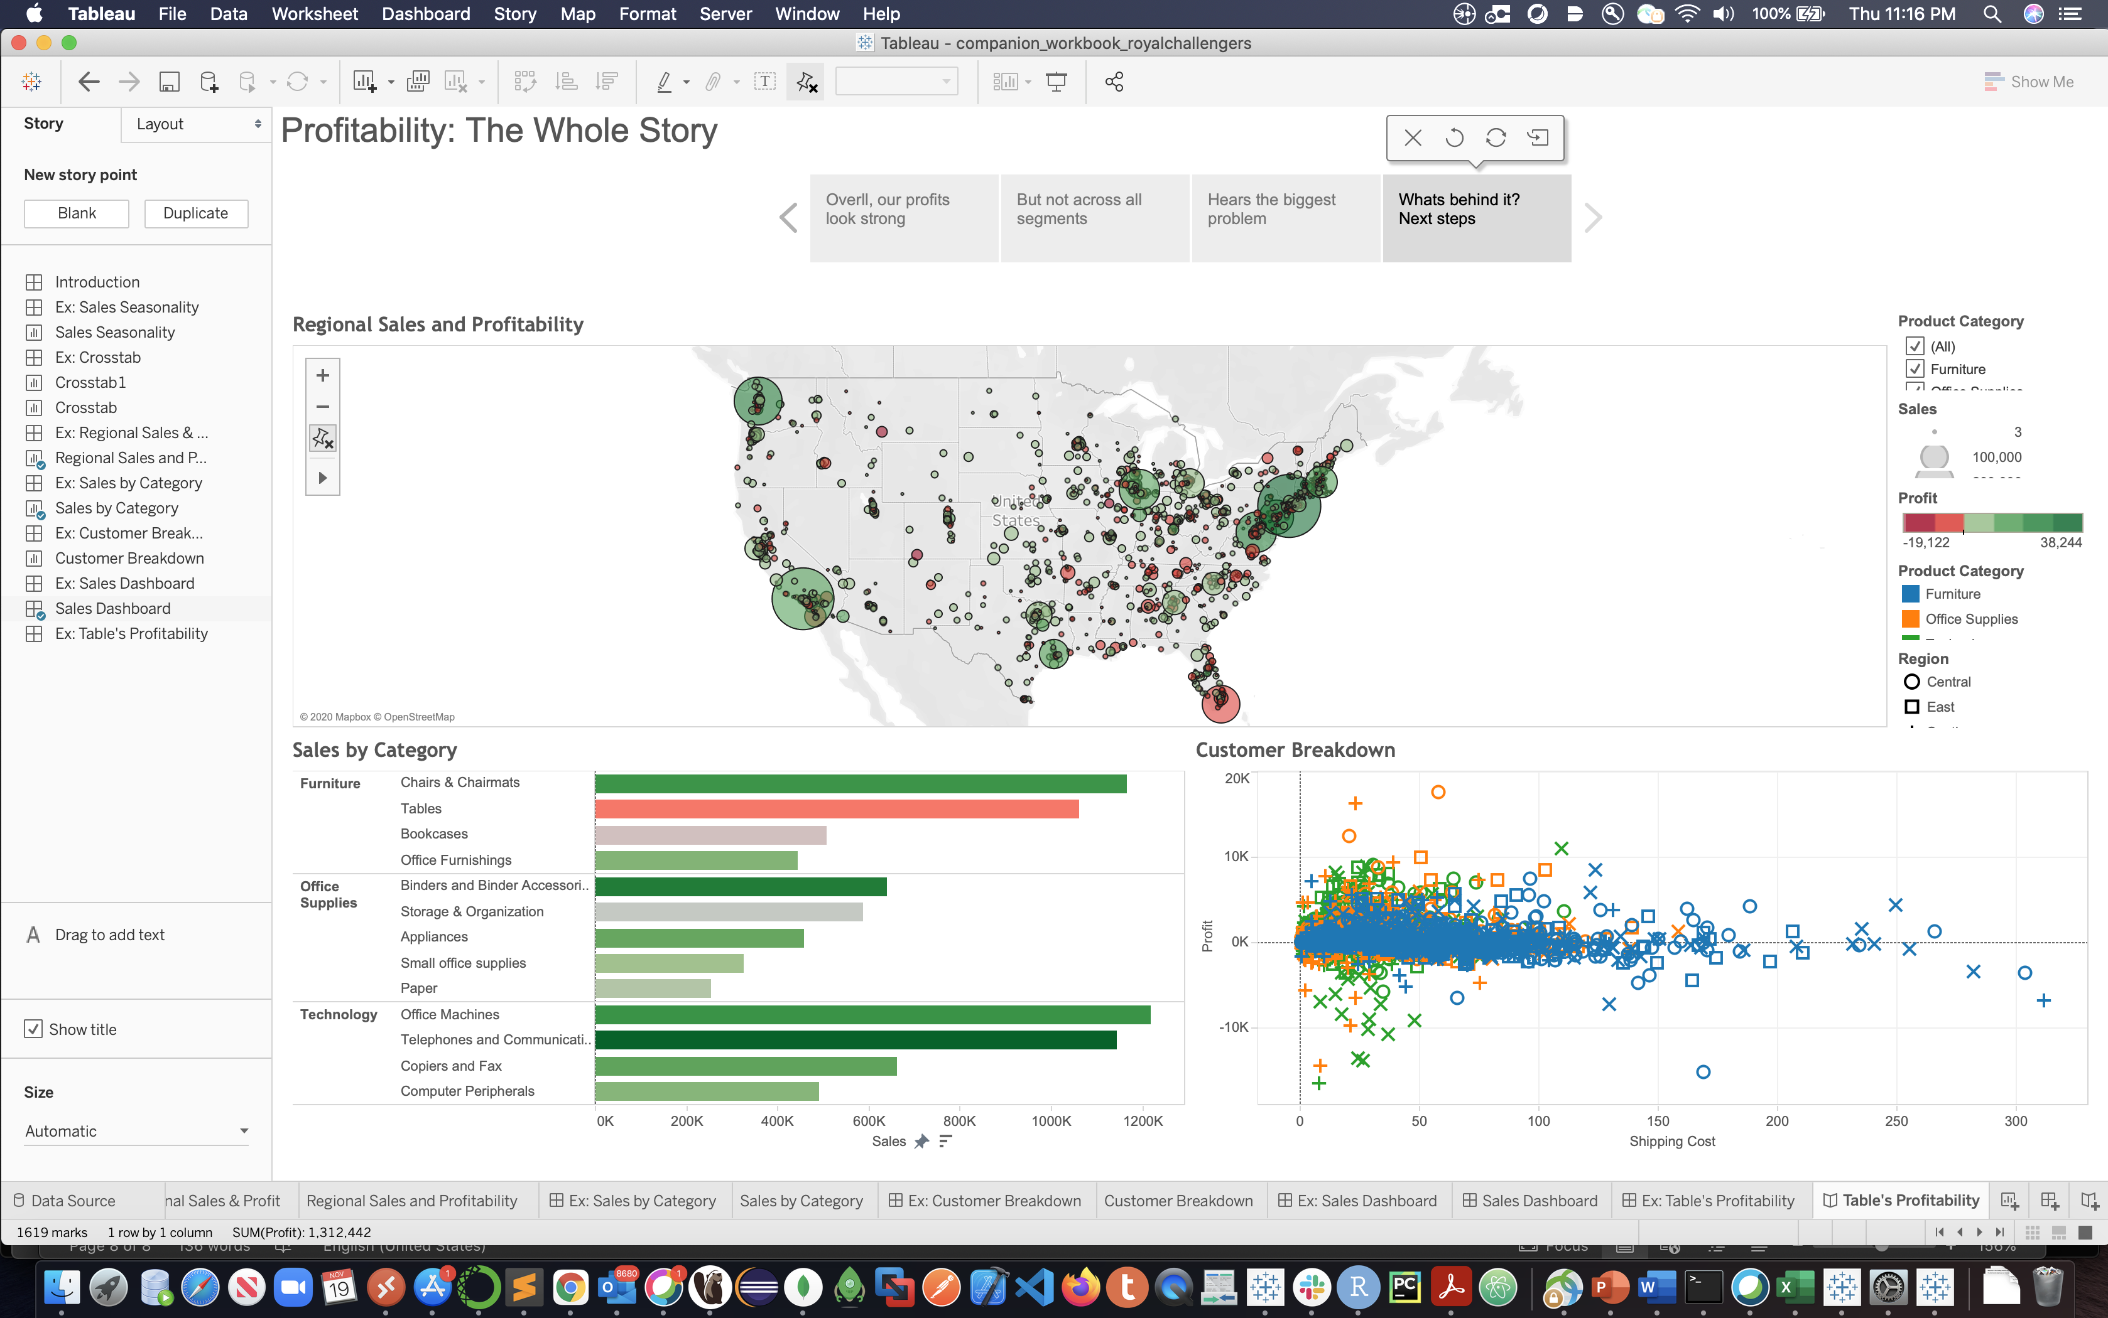

**GitHub Repository**

* URL: <https://github.com/royalchallengers272/Tableau>